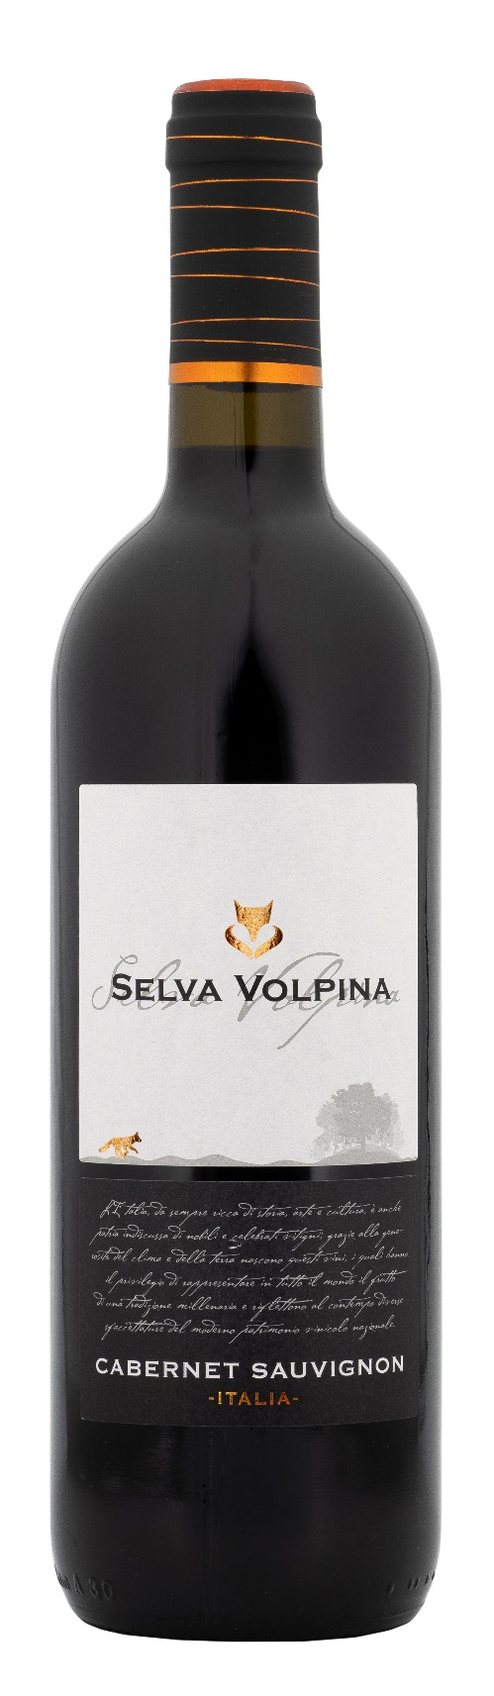
CABERNET SAUVIGNON ITALIA – SELVA VOLPINA

Grape: Cabernet Sauvignon 100%
Alc. Vol.%: 13
Vintage: 2024
Residual sugar g/l: 6,5
Total acidity g/l: 5,5
Production zone: Vineyards in Central Italy
Capacity: 750ml, 1500ml

CHARACTERISTICS

Vinification: Traditional peel maceration at a controlled temperature of 25°C for 10 days
Aging: 4 months steel tanks
Colour: Intensive and brilliant red
Bouquet: Fruity, with notes of spices and fresh peppers
Flavour: Full-bodied, warm with an elegant finish

SERVING SUGGESTIONS

Best enjoyed with pasta and rice dishes, red meat, roasts and aged cheese.
Serving temperature 18 °C
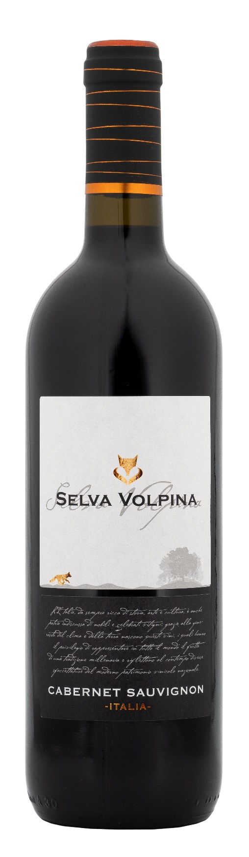
TECHNICAL INFORMATION / PALLETIZING

Size 750ml:
Article Nr. V10003A
GTIN-13 bottle 8017868003519
GTIN-13 carton 8017868002642
Closure Cork/Screwcap
Bottles / carton 6 bottles
Pallet size 80x120cm
Cartons/layer 25
Cartons/pallet 125
Kg/carton 7,2
Kg/pallet 925

Size 1500ml:
Article Nr. V10004B
GTIN-13 bottle 8017868002604
GTIN-13 carton 8017868004585
Closure Screwcap
Bottles / carton 6 bottles
Pallet size 80x120cm
Cartons/layer 14
Cartons/pallet 56
Kg/carton 13,4
Kg/pallet 790

Contains sulphites
GMO Free
Revisione 01. 14.05.2026

